IO.NETGARAGE

First step connect to the io.netgarage

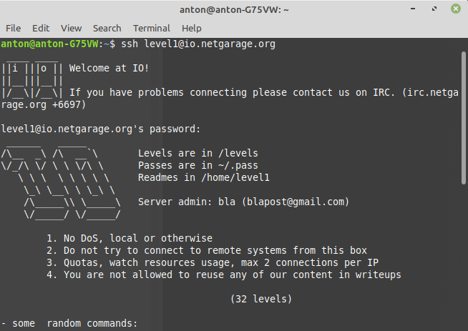Pic. 1 – start io.netgarage

level1@io:~$ cd /levels → go for package of levels

level1@io:/levels$ ls → can check all levels

Pic. 1.2 – levels list 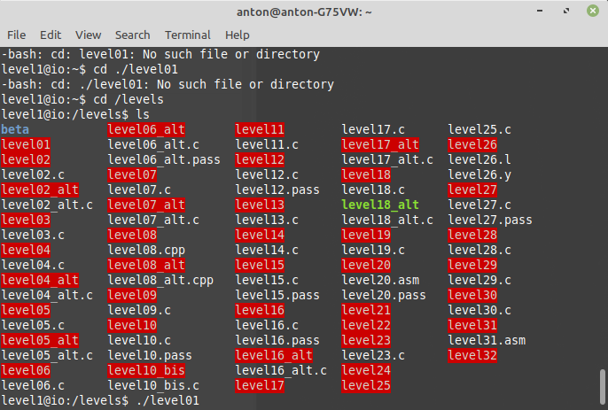

Go on the first level

level1@io:/levels$ ./level01

Pic. 1.3 – level1 (not correct result) 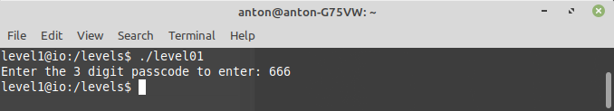

Need enter right passcode from go to next level

Passcode I can get with gdb (portable debugger)

level1@io:/levels$ gdb

Pic. 1.4 – 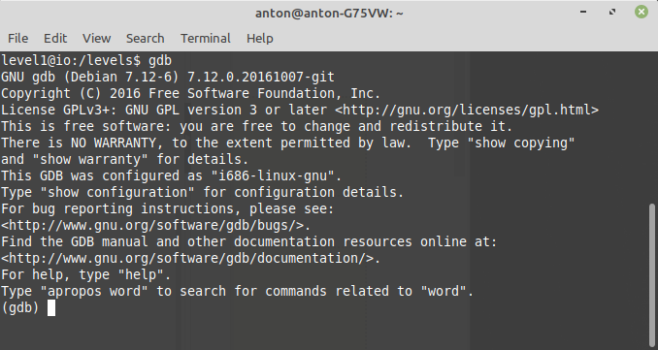run gdb

set disassembly mode intel and run disassembly main function

cmp – change value of flag

eax – register for operand (place where can be argument)

0x10f – place where is correct argument for change value of flag

gdb p – print the value of a variable

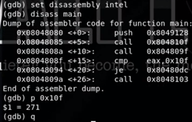

Pic. 1.5 – disassembly main function

After I get password for level2

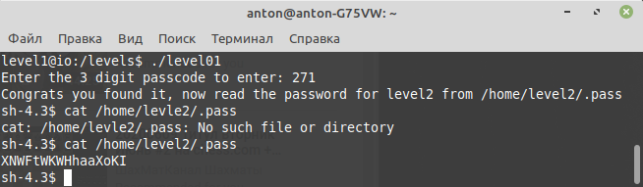

Pic. 1.6 – password to level2

Go to level2

SIGFPE – the signal sent by the process when attempting to perform an erroneous arithmetic operation

Pic. 2.1 – 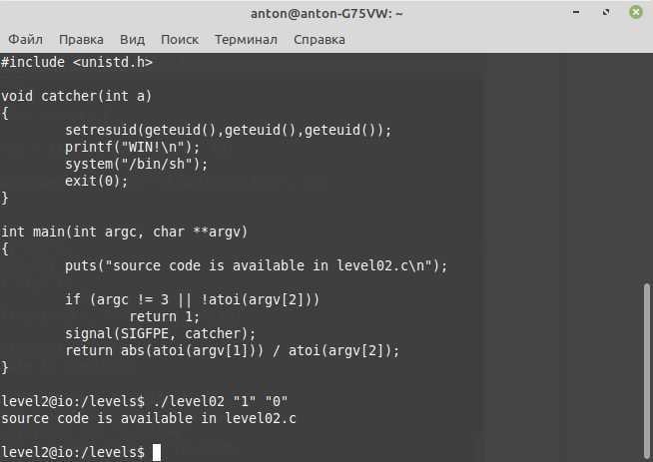level2, task1

The second task

In computer science, comparison with a floating point such as == can be very dangerous because it can never be true

NaN is a member of a numeric data type that can be interpreted as a value that is undefined or unrepresentable, especially in floating-point arithmetic.

Pic. 2.2 – level2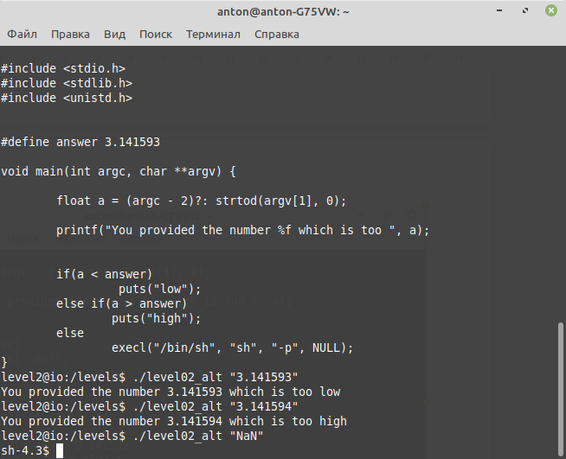, task 2

After I get password for level3

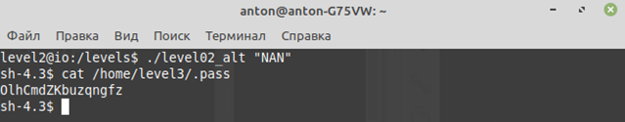

Pic. 2.3 – level2 password for level3